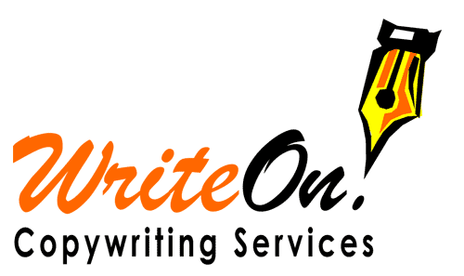 |  | Avda. Juan Carlos I, 65 – 5C  30800 Lorca  Murcia – Spain  www.write-on.net | Tel: (+34) 968 473 814  Mob: (+34) 686 254 295  andrew@write-on.net

Andrew De Gabriele, Freelance Copywriter

Blogging samples from sortedsites.com:
(Please note: some of the internal links may be broken)

15 minutes to revolutionise your Internet Marketing
May 26, 2009 · Filed under Online Marketing, Social Networking
In 2005, Forbes nominated the fish hook as one of the top 20 tools in human history. Ingenious, yet relatively simple to make and use, this tiny device revolutionised the life and diet of the costal and riverside dwellers who adopted it back then in the Stone Age.
Then, a good few millennia down the road, along came the net, and fishing was never the same again.
Now, what has this got to do with Internet marketing?
You see, if you rely solely on your website to generate sales, you are fishing for customers with a hook. It can work, you may be catching something, but at the end of the day you are severely limiting your potential. Meanwhile, there are others out there who are using the latest technology to haul in the real catches with their nets spread across a multitude of blogs, forums and other social media sites. Think about that!
In today’s Internet, your website is no longer the only place where online business happens, but you should be generating sales through a wider discussion about your company and products on a variety of other websites and social media. True, people will still come to your site to get in touch with you and complete the deal, but when they do so, many of them will be already sold on your products by the comments, reviews and other social chatter they have encountered on the wider social networks.
What it all boils down to is that online business is becoming increasingly decentralised. It’s not just about having a great website any more. This is the way forward for online marketing as we see it.
What you have to aim for is to create widespread discussions about your company and products, and to do that, you have to get out there and interact with your potential customers. It’s not terribly hard work, but it desperately needs to be done if you want to continue to make sales in the new online world.
An easy and painless plan to revolutionise your social marketing
You don’t need to invest massive amounts of resources and money to make social marketing work for you efficiently. All you have to do is to fill the bucket one drop at a time.
We strongly suggest that you get all your staff involved in the online social arena, not just the marketing department (there’s just too few of them). Ask each and every employee to set aside 10 to 15 minutes a day to follow our blueprint for making social network marketing work for your business. This could possibly be first thing in the morning, just after checking their e-mails. During the allotted time, they will write about the latest relevant news on your Twitter account, upload some new images to your Flickr account, post comments on your company Facebook page and reach out to the online multitudes through the other social networking sites.
Your staff must even – horror of horrors – post comments on other blogs and forums. Yes. You heard right. In fact we cannot stress this enough, because participating on other websites is an excellent way to get your company’s name out there in front of their visitors, so that you can then lead these people back to your blog or website with a well-placed link.
As you can see, your website remains the focal point and ultimate destination, and as such, you should keep it clean, easy to navigate and full of good quality product information. However, what you have now is a fishing net of social networking platforms that feed into each other, generate discussion and interest, and finally funnel visitors to your site to get the business done.
By building your social network bit by bit, you build up an ever-expanding net that is attracting potential clients from far and wide into your own online community. Best of all, several of these people will become converts and in turn help you to attract even more people simply by talking about your business on their own social networks, extending your catchment area even more.
How’s that for effective online marketing? Hop aboard now and make sure you’re not left stranded! 15 minutes a day is all it takes.

Get your business started in Social Media Marketing in 8 simple steps
March 20, 2009 · Filed under Online Marketing, Social Networking, Top Blog Posts
Social media marketing. Social network marketing. Web 2.0 marketing. Whatever you choose to call it, you know it’s the big thing now. It’s the way ahead. It has the power to change your whole business around. You know all that, but you don’t know where to start. Well, fear not! Just follow through these 8 steps to starting social media marketing for your business and you’re good to go.
- Sign up for a Gmail account using your company name (for example SortedSites@gmail.com) to gain access to a wide range of Google services. One of these is Google Docs, which lets you upload and share documents with the rest of your staff, so that the information is available from anywhere and everyone is updating the same thing. You’ll see why you need this in a second.
- One of the headaches of having accounts on many different social media sites is keeping track of all the usernames and passwords. It’s no fun having to try out a dozen passwords when you just want to get on with blogging about your newest special offer or uploading the photos of your latest staff party to your Flickr account. So we’re going to make it easy for you. Simply download this spreadsheet and use it to manage all your usernames and passwords. Upload a copy to Google Docs, grant access to the people who need it and make sure it is kept updated so that everyone will have all the information they need at their fingertips.
- Start a blog for your company and update it regularly. Your blog will become one of the mainstays of your social marketing campaign. It will let you establish your authority in your field. It will help you build a relationship with prospective clients and find out what they have to say through their comments. It will improve your search engine rankings. All that and much, much more. If you don’t have a blog, you desperately need one. You can either get a free blog on one of the many hosting services available, line WordPress or Blogger, or if you want to have full control of your blog, its appearance, and most importantly, its contents, we can set up your blog for you with a customised look and feel for as little as 500€.If you already have a blog but it’s a little weak at the knees (or it’s doing well but you want to make it even more effective) then learn some tips and tricks you can use to give your blog some much-needed gene therapy.
- Get accounts in your company name on the main social media sites, such as Flickr, StumbleUpon, YouTube and Twitter. Also, build a FaceBook business page and encourage your staff and clients to create accounts on LinkedIn, so you can tap into each other’s business networks.
- Log in to each of these accounts and update your profile as best as you can. Put up photos or videos of your staff, your offices, your work, and your clients (with their permission). Post links to your website, your blog, your client’s websites and anything else that could be useful to your audience. Include as much information as possible so that whoever comes across your profile page can start to get to know you right away.
- Actively participate in the different communities on all these social media platforms. Don’t just share your stuff and publicise yourself. Comment on other people’s photos. Comment on their blogs. Comment on the websites they share. Comment on their comments. Of course, as you do this you will want to focus on things that are related to your business or that are of great interest to your target audience, so that you make sure that you are communicating with a group of people who are indeed your potential clients.
- Register for Google Alerts for your company name and for the names of your products to be notified whenever Google finds some new web content that is talking about your business. When that happens, post comments, say thanks for the mention, and expand your social network.
- Search Google for keywords related to your industry to find websites, blogs and forums that belong to your field. Participate in these communities by commenting, sharing your own opinions, and building new relationships with like-minded people.
Now that you know what to do, it’s time to get started!
Social media marketing is not only very effective in its own right, but it is also a great way to market your business for a very low cost, and more and more companies are embracing social media marketing as a way to tackle the current economic downturn.
What are you waiting for?

The pluses and minuses of Google+ Brand Pages for businesses
November 11, 2011 · Filed under Online Marketing, Social Networking
The wait is over, and the Google+ brand pages are finally available to any business that wants to boost its online visibility.
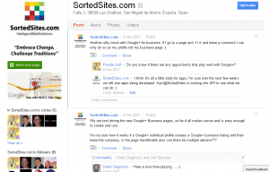
While sceptics may rush to remind you of the flops of that were Google buzz and Google Wave, we don’t think that is relevant to Google+ and the new brand pages in particular. The reason is that Google is integrating Google+ very strongly with other Google products that already have a very strong user base, starting from its most widely used product, the Google search engine.
When people search for something while logged into their Google account, they will now see relevant Google+ brand pages that people in their Google circles have +1’d. It goes without saying that a +1 vote counts as a personal recommendation, and users are much more likely to follow a search results link to a page a friend likes. This is a huge advantage over Facebook pages, and a very big incentive for you to build your Google+ brand page and get friends and customers to +1 it. Besides, people can simply search for +yourcompanyname (adding a ‘+’ sign before your company’s name) and your branded page will show up. So far, so good!
You can already measure Google+ performance with Google Analytics and we are looking forward to seeing how Google will tie in Google+ and these brand pages with its other platforms like Gmail and Android,. If they get it right (fingers crossed!), the most exciting times for social network marketing may be just round the corner.
With that in mind, there are a few non-trivial niggles with Google+ brand pages as they are right now, as Robert Scobles points out in a rather pessimistic post. We’d like to hope that Google can iron out the issues and get on with a number of things we want to see implemented.
For example, at the moment, you can only manage your pages through one Google account and this is a problem for companies that need to put several people in charge of a brand page. Also, because Google requires accounts to be in the name of a real person, it’s not as simple as creating a dummy admin account for everyone to share (which itself has its drawbacks). Come on, Google, fix this quickly so that social media teams can easily work together!
We expect Google+ brand page management and Google Places page management to become integrated sometime soon. Also, how about a mobile app to publish photos directly to your brand page as you can do with Facebook, Twitter and Flickr? And why can’t Google+ business pages give a +1 to websites that the company likes?
We really want to see Google+ succeed because of its immense potential to be integrated with Google’s other platforms, as we already mentioned. Hopefully, someone over at Google Labs is paying attention to what people are saying and is busily cracking their whip. With a bit of luck, we’ll see something to get really excited about in a forthcoming update!
In the meantime, see how other businesses are developing their Google+ brand pages and create your own.
Also work on integrating your social media accounts with each other by using the same GMail address for your Facebook, Twitter, Google+, etc. In Google+, build your network and organise people into different circles that represent your relationships with them. For example, you can have a circle for clients and another for prospects. Or you can have separate circles for people who use your different products or services. In this way, you can target your posts at specific groups, so that people only receive information that is relevant to them. This also gives you the flexibility to present your message in the best way for each group, or to publish open posts when you want to reach everyone at the same time.
So, while you’re waiting for those updates to Google+, there still is a lot you can take advantage of right now. Go for it!

Get ready for Google’s new Plus 1 social voting!
May 27, 2011 · Filed under Online Marketing, SEO, Social Networking
What do you get when you cross Facebook’s “Like” button with the world’s most popular search engine? Well, it’s Google +1 (or Plus 1)!
As we’ve often discussed, Google is always working on ways to make their search results more relevant and more in tune with what people are actually looking for. Now they are taking their Social Search to a whole new level with the introduction of Google +1 .
The basic concept is one you’re all familiar with. Google +1 lets people with a Google Profile vote up content they like, much in the manner of Facebook’s Like button. What is very exciting in this case, however, is that Google will be rolling out +1 across its search results. The idea is that when you search on Google, you get to see what links people in your Social Circle have +1′d. And (even if you are not logged into your Google Profile) you will also be able to see how many people have voted up the different search results Google presents you with.
[Embedded video: Introducing the +1 button http://www.youtube.com/watch?feature=player_embedded&v=OAyUNI3_V2c ]

+1 is still in an experimental stage and available on English searches at Google.com Try it out here! Keep in mind that as Google says, your +1s are public, but you probably already realised that.

How to take advantage of Google +1 for your SEO
We have long said that social voting is going to have an even greater influence on the search results than it already has, and it looks like 2011 will be the year this happens, once +1 becomes official. In the meantime, you need to get ready so you won’t be left behind!
When people go through their +1 enabled search results, they will be paying much more attention to the links that other people have voted up. It’s basic human nature to reach the conclusion that if something is popular, it must be good. Now SEO is going to be as much about getting your links +1′d as it is about search engine rankings.
However, if you think there are easy shortcuts to +1 glory, Google’s track record of detecting those who try and game the system means that you’re probably mistaken.
Once again, Content has been confirmed as King! This makes it very important that you create original and useful content that people will not only like, but also +1, and the same old rules still apply. Write for your audience. Share your knowledge and expertise and make sure that your website and blog content is absolutely top notch. Build an awesome collection of content that will make it easy for you to ask for and win people’s +1 votes when this service goes mainstream.
At the same time, you need to get a GMail account and build on your Google Profile. Companies that are connected through Google will have the extra advantage of showing up as +1′d in searches by people in their social circle. And you’ll also be able to help the websites you like by giving them your vote!
Google’s +1 places the emphasis on creating great stuff that people will like, and that can only be a very good thing, not only for the Internet, but also for all of you who have something really worthwhile to say!

2 new Facebook business page features you must take advantage of!
February 23, 2011 · Filed under Online Marketing, Social Networking
Facebook is probably just as famous for its ever-changing options and features as it is for connecting old schoolmates and ushering a whole new world of social media marketing. This time, though, there’s plenty to be excited about the latest Facebook business page changes if you are using Facebook pages to get your name out there (and you really should).
A few of the changes are just cosmetic, like the new photo showcase up top and the navigation menu that has moved to left, in the same position as on standard Facebook pages. However, where the new style Facebook business pages have really come into their own is the way they let you interact with your audience, both on your own page and on third-party pages as well. Here are two of the changes that we absolutely love:

1. Comment on your business page as yourself
When people come to your Facebook business page, they would probably much rather interact with a human being than with a ‘faceless’ company. It looks like Facebook have finally taken notice of this, and you can now comment on your business page in your own name. You will have to activate this feature before you can use it. Don’t worry, it’s just a quick flick of a switch!
Go to your Facebook business page settings and you will see a checkbox that says “Always comment and post on your page as YOUR BUSINESS PAGE NAME even when using Facebook as YOUR PERSONAL NAME.” Simply uncheck this setting, save changes, and you’re done!
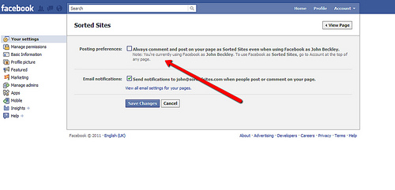
Once you set this up, you will find a new option on your business page that lets you use Facebook in the name of your business page again. You can also switch identities between your page and personal accounts by clicking on the ‘Account’ tab on the top-right of Facebook.
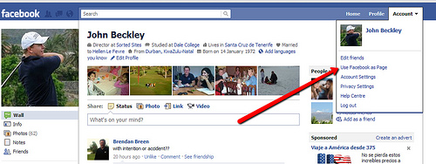
This brings us to the other new feature that we think is absolutely awesome:

2. Comment on other business pages as your business page
Yes, as the heading says, you can now comment on other business pages in the name of your own page, and not just using your personal account. If you are in the B2B market, like we are, this opens up tremendous opportunities for your company to reach out and interact with your clients (and their clients) on their own Facebook page.
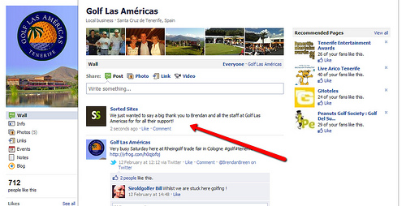
Another great way to use this new feature is to comment and interact on the Facebook business pages of other businesses that are related to yours. For example if you have a hotel business page, you would post comments on pages of local restaurants, golf courses, and other events and entertainment venues. Also encourage these other companies to do the same on your page, to spread the love (and potential clients) around.
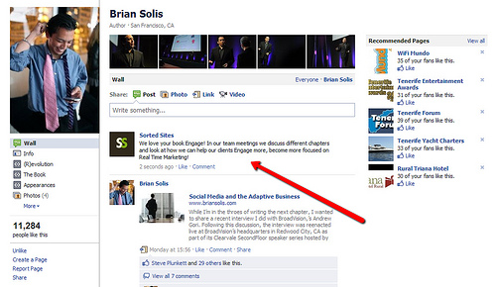
There is only one downside to this feature that we can see: it can be used for evil, to hijack a competitor’s page with your comments. It goes without saying that this is terrible form and does you no favours, so don’t!
To use this feature, you need to enable the ‘Commenting on your business page as yourself’ feature and then select the ‘Use Facebook as your page’ option, as we described above. If you are the admin of several pages, you get to choose which page you want to interact as. And finally, you will also have to ‘Like’ the business page that you want to comment on before you can do so.
These two features open up lots of amazing opportunities for you to spread the name of your business around on Facebook. Remember to always be gracious and courteous in your interactions, even when other people are not. Your potential clients will be forming an opinion of you based on what you say and do.
While we’re very excited about these new features, we don’t blame you if you feel that whenever you think you’re getting the hang of Facebook, they come along and change the rules of the game. Facebook offers you plenty of information about their business pages in the Pages Guide, Resource Center and in the Help Center.
And if you’re feeling a little overwhelmed about how to make the most of your Facebook pages, or if you’d rather spend more time running your business, just contact us at Sorted Sites and we’ll be delighted to help you out!

How Google uses social media to determine its search rankings
January 25, 2011 · Filed under Online Marketing, SEO, Social Networking, Top Blog Posts
Back in 2008, we spoke about the shift we were seeing in SEO practices, and we explained how using the social media to get people to talk about you online is the way forward. Since then, we’ve seen countless examples of the power that the social media has to rally people around a company, or against it. Social networks like YouTube, Facebook and Twitter have brought publishing within your reach and made it possible to get tons of attention for a very low cost. You’ve surely heard of BlendTec’s Will it Blend campaign, on one end of the scale, and of the furore caused by the United Breaks Guitars video on the other.
Then, last June, we saw how Google’s new Caffeine Search made it more important than ever for you to take your social media marketing seriously. We insisted that you need to get active on the social networks because your posts, tweets, Facebook updates and so on were becoming more and more important for SEO and Google was actually showing them in search results.
Well, last December, Google’s Matt Cutts gave some very interesting insight into how Google uses the social media in its search rankings. Watch the video below, where Matt responds to this SEO article’s discussion of the social signals that Google and Bing use in their metrics.
Matt Cutts explains that social media SEO is all about using social media to build your reputation online, and not just about the raw numbers of followers you rack up on your accounts. It looks like Google is much more interested in quality, rather than quantity.

[Embedded video: Does Google use data from social sites in ranking? http://www.youtube.com/watch?feature=player_embedded&v=ofhwPC-5Ub4 ]

Google wants to determine how important your company is, based on what is being said about you in the social media, and they are using this knowledge to influence your search rankings. Right now, this is happening primarily in the real-time search, but Matt makes no attempt to hide the fact that Google is seriously looking at expanding the use of these techniques into the general search as well.
So, what do you do about it? Now, more than ever, it is vital that you use and monitor the social media to cultivate a solid online reputation for your company. You need to establish a strong presence on the main social networks, attract a core following, and keep your finger on the pulse of what is being said about your company.
As we have said already, this task is no longer one that you can afford to assign to one or two of your staff and leave them to their own devices, to make a few posts whenever they feel like it. Your company needs to become more organised and more consistent with your social media strategy and the way you execute it.
Take a look at how we used the social media to market the Tenerife Ladies Open, last year. This is the kind of team effort you need to work with. Read through our post on starting a social media team and make a similar plan work for your company too.
In a nutshell, you need to:
- Identify team members
- Choose a leader
- Decide on your social media strategy
- Set concrete tasks for the individuals on your team
- Evaluate your progress with regular meetings
- Keep up the effort in the long run
If you are not doing this already, it is high time you get started. The truth is that doing social media the right way is easy when you break it down into smaller tasks. It also costs next to nothing, and your own staff can learn to do pretty much all the work as part of their daily routine.
So get working on your social media strategy today, and if you want to discuss it with us, just let us know.

REVEALED: How we marketed the Tenerife Ladies Open online
September 20, 2010 · Filed under Online Marketing, Social Networking, Top Blog Posts
With all the interest that the Tenerife Ladies Open has generated, we thought we’d give you in inside look at the internet marketing we did behind the scenes, and show you how we went about creating online buzz before, during and after the event.
First off, we want to say that this was a team effort that we undertook together with our sister companies TenerifeMagazine.com, CanaryPR.com and our friend Bill, a.k.a. SirOldGolfer, and we take this opportunity to thank everyone for a job well done.
And now, on to the juicy details!
We started off by making contact with the players who were already on Facebook and Twitter before the tournament, and engaged them and their fans in an ongoing conversation over the social media. We also made friends with some of the sponsors, such as Poodle Clothing, and took an interest in what they were up to, even giving them some exposure through our own social media networks (see screenshot below). The idea is to rope in as many interested parties as possible, so that we all help each other out and cross-promote each other.
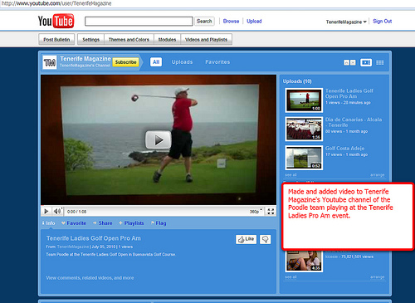
At the same time, we got to work, devoting a whole section of Tenerife Magazine to the Tenerife Ladies Open…
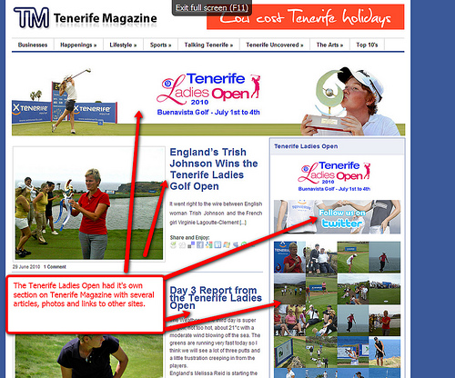
… and, throughout the tournament, we kept readers updated with the very latest news. We also linked to the hotel, golf course, other relevant websites that would be of interest to the golf fans.
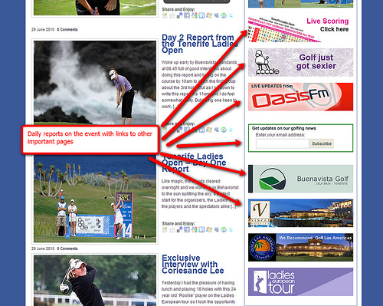
We also reached out to as wide an audience as possible by writing press releases about what was going on and distributing them through a variety of media outlets, including CanaryPR.com, of course.
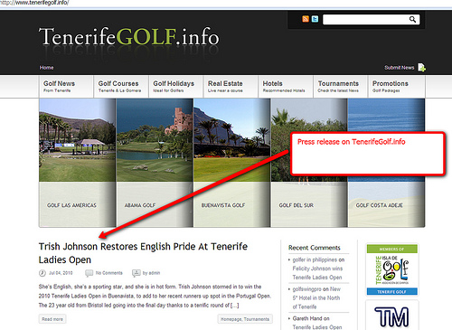
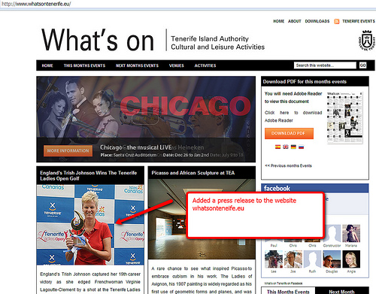
Soon enough, we were getting results, both for general search terms…
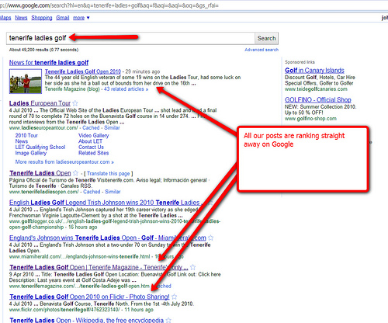
…and also for the names of top-ranking players:
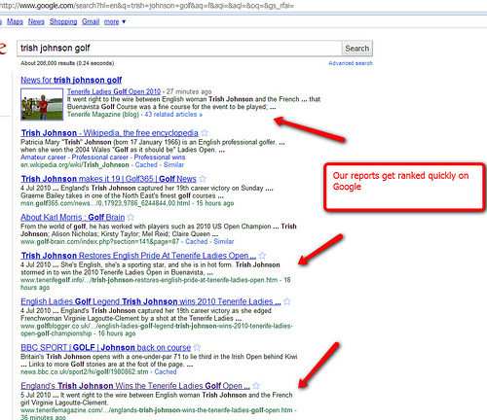
Here are some more search results that we achieved by writing interesting articles that other people will want to link to:
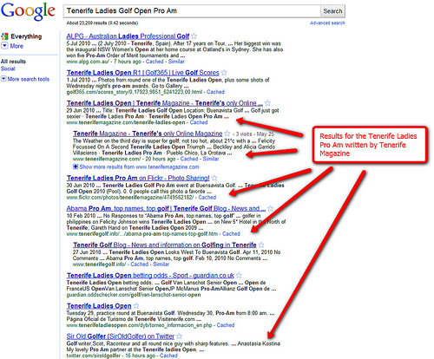
If you look closely at the above screenshot, you can see Tenerife magazine’s Flickr photo album also doing really well in the search rankings. This is what we mean when we go on and on about the potential of well-tagged photos in Flickr.
Throughout the tournament, we kept our cameras snapping and promptly uploaded the photos.
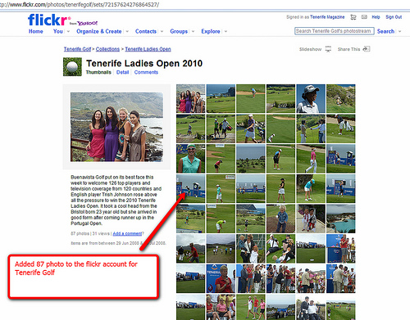
And our hats go off to SirOldGolfer who holds the record with all the photos he uploaded onto his Picasa account.
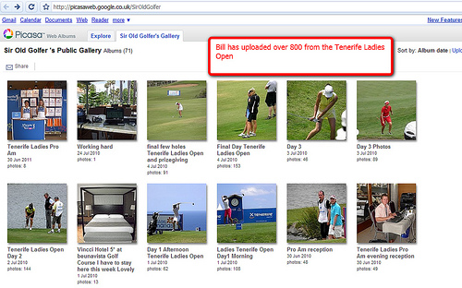
One thing to keep in mind is that Flickr is much more than an online photo album – it is another social network, where people can share images, post comments, and interact online. This is why we created a public Flickr group, specifically about the Tenerife Ladies Open, and invited everyone to upload photos and join in the fun.
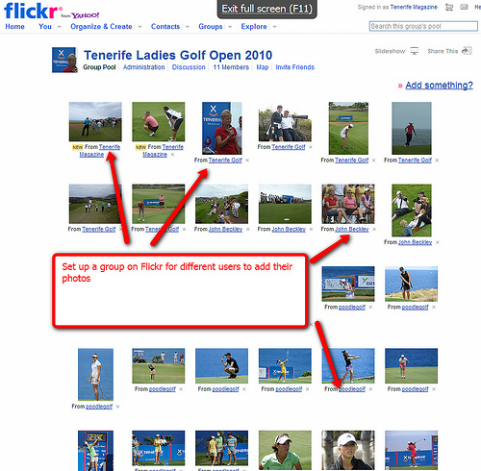
We also uploaded photos to Facebook…
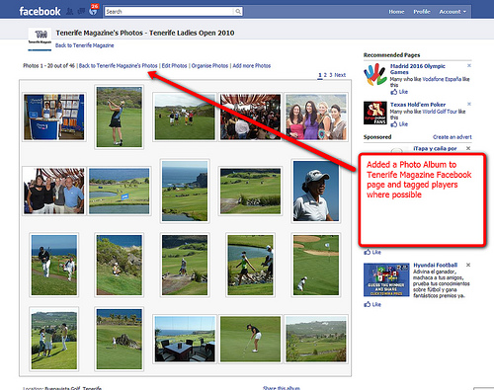
…and we used Tenerife Magazine’s Facebook page to link to and promote a variety of articles and blog posts about the Tenerife Ladies Open.
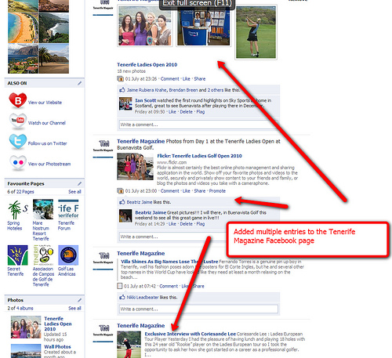
The Twitter social network was an excellent platform over which to publish brief, up-to-the-minute results and commentary on the Tenerife Ladies Open.
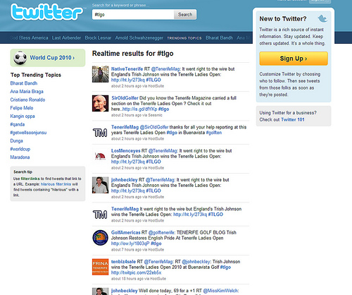
And, as you can see, Twitter proved to be another very successful way to make it into the top spots of Google’s search results. Our Twitter posts got recognised as news and ranked higher than a full-blown article.
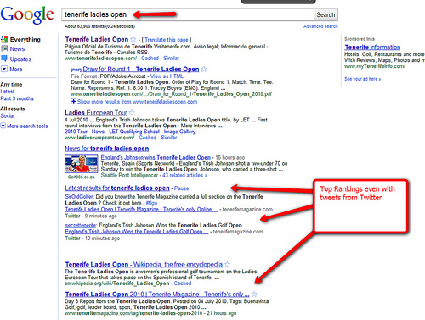
Once the tournament was over, we continued to keep in touch with golf fans and players alike, and when Trish Johnson, the winner of the Tenerife Ladies Open went on to claim the first place in the French tournament, we made sure to congratulate her on the French tournament’s Facebook page.
As you can see, social media marketing is all about reaching out to people in a large variety of ways, and the more people join in, the merrier! Once again, we call out to the people of Tenerife, and especially to those with an interest in golf, to join in this collective effort. Let us all make a special effort to get more involved online, to befriend and engage the foreign golfing pros, amateurs and fans of the sport, draw them into the conversation, and thus promote the sport on our island.

Keep up the momentum, to succeed in Social Media Marketing
October 18, 2010 · Filed under Online Marketing, Social Networking, Top Blog Posts
Social media has drastically transformed the marketing landscape and the way businesses connect with their customers and audience. And yet, despite the fact that building your own online community is an extremely powerful way to reach more people than ever, things simply don’t happen at the flick of a switch. It’s not instant magic. Sorry. If you thought otherwise, blame the hype.
Whether you are just starting your social media campaign, or you have been working at it for a while, you need to realise that this is a gradual process. In the same way that you don’t make a crowd of new friends overnight, building a social media network of loyal followers for your company takes time and commitment. Your social media campaign will give you results, provided you keep at it and work on building your online relationships.
It’s not enough to set up a number of social media accounts and then forget about them. You need to be regular and devote time to each online community you decide to interact with. The same goes for your blog. Unfortunately, many people fail to succeed in social media marketing simply because they lose interest, or they don’t keep up an ongoing effort.
The fact is that it’s better to have no social media at all, than a bunch of neglected accounts. Think about it. What impression do you get when you see a company that hasn’t posted anything to its Twitter feed or Facebook page in ages? Or, what does a blog say about its owner when the last post dates back to before the summer? Yet, that is exactly what many companies do, and some of them even post their abandoned social media feeds on the home page of their main website for all to see.
So, how do you avoid biting off more than you can chew and work towards your success when it comes to social media?
Choose 5 social media platforms (say Facebook, Twitter, Flickr, YouTube and your blog), or whatever you can comfortably manage, and make sure you can devote enough time to them. Put in your very best and give regular attention to each community.
Update your blog regularly with fresh posts that appeal to the kind of readers you’re after. Approve and reply to comments as soon as possible, to show your readers you care and encourage them to post again in the future.
Post regular photos, news, comments, and other content to your company’s Facebook page. Engage your fans and start discussions on your wall. Comment on other people’s profiles and make your presence felt.
Don’t just upload new videos to YouTube. Make contacts, add people as friends, ‘favourite’ videos you enjoy, post comments and interact with the community.
On Flickr, join groups that interest you. Also form your own group and invite people with similar interests to join. Make friends and comment on other people’s photos.
Be active on Twitter. Follow people you like and re-tweet messages that you think your followers will appreciate.
Get active on LinkedIn. Recommend people you have worked with, and suggest that they do the same for you. Join common-interest groups, engage in discussion, answer questions that relate to your area of expertise in the LinkedIn Answers area.
Also remember to use your different social media accounts to cross-promote each other. For example, if you have uploaded a new photo set on Flickr, share them via Facebook, Twitter and Linked in. You should even link your different profiles to each other and get a Google Profile to contain them all in one place.
Keep in mind that you don’t need to spend all day on the social media to see results. However, you do have to be regular and keep active. Come up with a workable strategy and then make sure you stick to it. Have patience, evaluate your progress, and with time, you will see the results you expect from your social media marketing.
Good luck!

